# Semester Project Milestone 2

***This document contains all the information regarding the project of the semester for Advanced CSS DGL 203. Where it will be documented the progress and what needs to be accomplished.***

***The progress of this project will be documented in this repository [mariaelenacossio/DGL203-Project]***

## Project Summary

* + This is a local business located in a small town in Mexico and it’s currently on development in the food industry where it requires of a high-quality website, which in this case does not meet any of the UX/UI principles, so this is a basically a white canvas that I can work with in order to achieve a functional and reliable website.
  + The main goal to reach a broad range of local consumers who are interested to support local business and who are interested in the products that are offered such as confectionery, sweets and event packages.

## Website Goal(s)

* + The goal of the website is to tell people about the business and that is essential to have an online presence.
  + It will help to grow and achieve business objectives and it’ll serve as a tool to lead the audience, create brand awareness and client retention.
  + The website will follow the UX/UI principles and effectiveness in the back-end to ensure its functionality and affordance for a better user experience.

## Content Priorities

* + Testimonials, contact forms, a well thought out display of the menu and how the product can be delivered to their door as well, the location of the business for those who would like to dine-in.
  + The primary content is to catch the attention of the targeted audience and then engage them with content that direct them to the product that will most likely to interest them to finally, encourage them to potentially place a delivery or an online order.

## User Personas

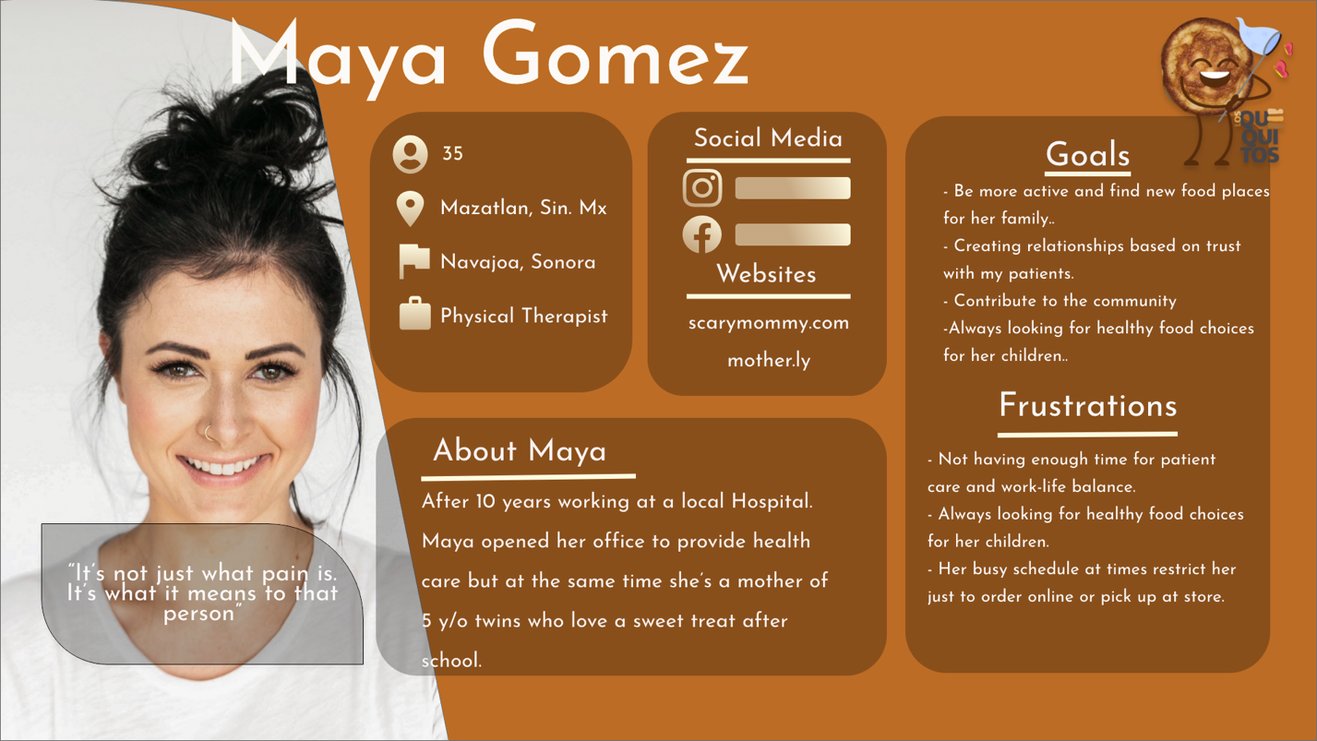

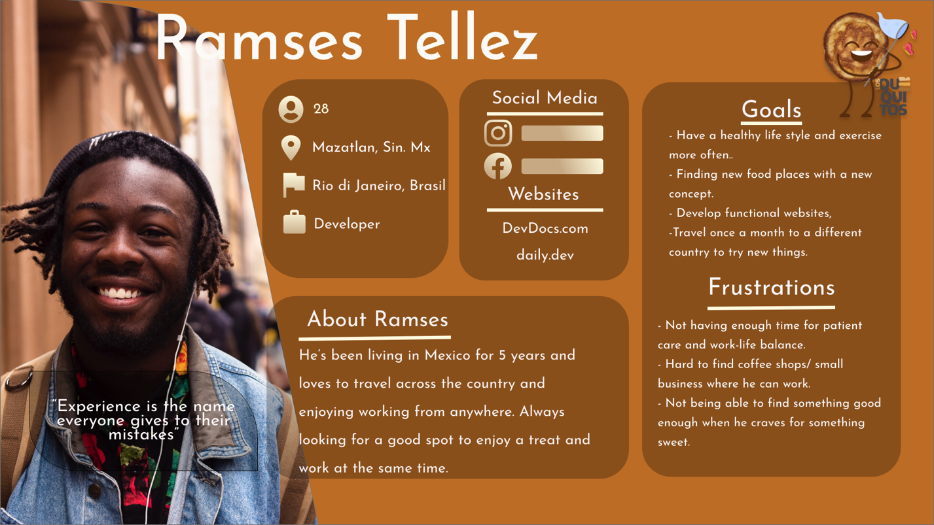

## Similar Websites/Competitors

* + New York Mini Donas.

This business does not have a website, only has social media presence and delivery service through third party sites.

* + - Facebook Page: https://www.facebook.com/NewYorkMiniDonas/
  + Rock&Donut.

The business offers a larger variety but it does not have a website, just social media presence, unfortunately at the moment is temporarily closed.

* + - Facebook page: https://www.facebook.com/rockndonut/
  + Montoneras Donas.

The business is the only one among the similar business in the area that has a responsive website offering a quote for those who seek larger orders through a contact form. It does not follow the UX/UI principles and the layout of the site is poorly thought out. Also, offers third party delivery.

* + - Website: https://montonerasdonas.negocio.site/?utm_source=gmb&utm_medium=referral

## Advantages over Alternatives

* + The design will me thought out effectively along with the layout of the information and maintaining the identity of the brand also, the framework am using which in this case is bootstrap will allow me to handle details in better and effective way. Since am building this website from scratch the flexibility of the framework perhaps is going to be in my advantage.

## Call-to-action priorities (Success/KPIs)

* + Design a landing page in which the head-line and sub-headline describe in a brief but effective way for the user to understand what is the site about and as well, encourage them to click in the right button to have more information and as well, try to get them submit their email so we can keep them and update them with news. There will be a couple action buttons for them to click on and redirect them to the information that will engage them.
  + Regarding the KPIs we can monitor them with the metrics in Google Analytics to track the traffic and how people are finding the website. As well, embed a XML sitemap so the source of the URLs can be easily crawled by Googlebot.

## Sitemap

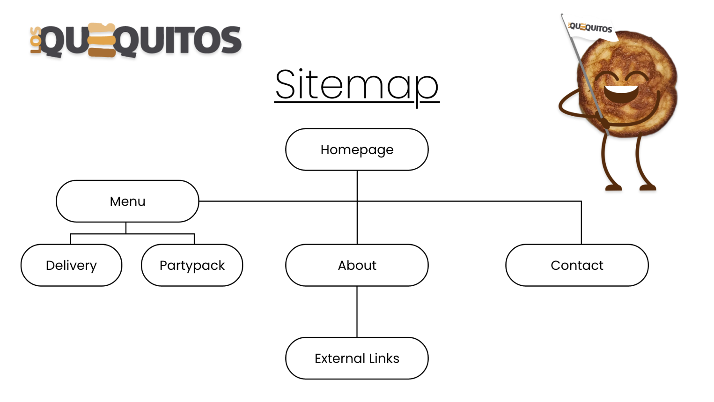

## Look and feel

* + The site will be design according to the identity of the brand with a minimalist, clean, playful and professional look.
  + The content will be written in a voice tone where the audience feels invited and welcomed to try something new.
  + A vibrant palette of colors in brown accordingly to the product and with fun details.
  + They have a logo, backgrounds and SVGs to work with and add some animations.

## Comments/Suggestions from a classmate, peer or interested person

* + Regarding this website I have a few annotations/comments about what methods can be applied to turn this into a successful project. First of all, it’s essential to understand the value of having KPIs because in the bigger picture those will drive the visitors in your website, and to prevent and avoid some barriers from your user to covert to the site and hook them to convince them to take action.
  + Perhaps adding a modal that sits on the edge of the page where users can click the button to rate their experience. The layout of the pages based on the wireframes works well for the kind of industry and market is targeted but at the same type is important to keep in mind the illustrations/images and their size will affect the loading of the site and as well, their functionality and display on other devices.
  + Practice some industry standard format to help to eliminate and facilitate the development.
  + There’s a need to create rich and effective content for the SEO to position it among those sites related and potentially make them click to land on the site in the matter.
  + Nonetheless, styling, formatting, design patterns and naming conventions in your code so it’ll be easy to recycle along the site. Also, understand if every chunk of code is needed and if it fit into the project.

-Abedin Poonawala. (Developer)